The Real Deal on Making a Healthy Stream of Income on ebay on a Daily Basis

By: Kevin Nurmi

Thank you for your purchase of this WSO. You may do whatever the heck you want with this WSO, give it away, sell it, modify it, whatever!

Note: This is for informational purposes only. I make no guarantee on your success or failure

Introduction

Ok, straight up, this is going to be raw instructions, with some images along the way. I really don’t have much time to monkey around with this report and make it all pretty with graphics and stuff. I am also not going to say “ebay is the #1 auction site, with over a zillion people shopping there everyday. It’s a goldmine!” Everyone knows that. After all, I want you to get out and make some money right?
The main plan for this income stream is to setup your own ebay store, sell physical goods via dropshipping, and make good money doing it. Depending on what you are selling, and the quality of your items and designs, you could be making anywhere from an extra $20-$150 a day. That’s $560-$3000+ per month!
Here is a RECENT screenshot of my paypal account. Isn’t it funny when you see websites selling something and have a screenshot of their adsense, clickbank, or Paypal account that is like 2 years old!?!? Seriously!!! I will show you how to be like this everyday:

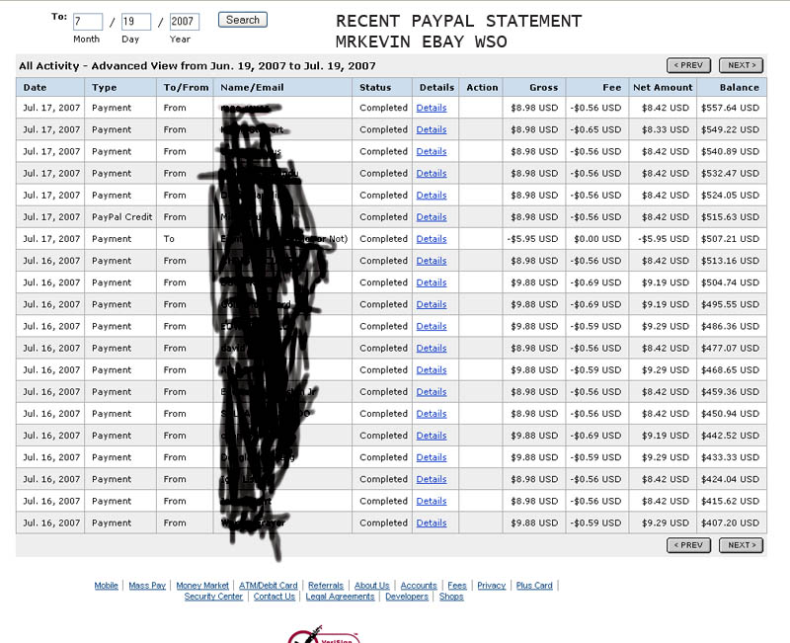
Step 1

The first thing you need is an ebay account. Duh. If you already have one with some feedback established, that would be great. You can get started right away. If you have to create an ebay account, go to www.ebay.com and register a new account. You will need to build up some feedback. I would recommend doing this by buying .49c, .79c, or .99c auctions. Unfortunately ebay is cracking down on the .01c auctions since everyone just uses them as feedback. Be careful. If you need to buy these go to “Buy – Everything Else – Information Products” or just search for “ebook”

You will also need a paypal account. Go to www.paypal.com if you do not have one. Make sure your address is verified and you have a business account. This is so you can accept credit card payments from customers through paypal and you can receive a mass quantity of payments as we will be flooding our paypal account.

Finally, we need products. Where do we get these products? We are going to use my supplier, artscafe.com. The nice thing about this website is that your product line is unlimited. You will create your own products, which can make your store unique. They sell customized watches, coasters, t shirts, charms, and more! Register for a reseller account at www.artscafe.com. The best part is YOU customize the product. You simply find an image, upload it to your account, and select what products you want to put your picture in. Note: Membership is $20 a month, payable via paypal. Also, you get a 30 day free trial, check it out. I don’t get any affiliate commission when you register. This is our dropship source. This company is based in Hong Kong and will ship anywhere in the world. Generally speaking it takes 7-10 days for product to arrive to customer in the US, and maybe a bit less in other parts of the world. My customers left me feedback saying fast shipping. We will be create inventory, sell the item on ebay, get paid from our customer, buy the item directly from the artscafe website, and have it dropshipped right to our customer. The best part is EVERYTHING is done online, and artscafe prices are SHIPPED prices!

Also, I will get into digital products. When I get more time, I will add digital products to my ebay store. The best digital products to sell are GNU public licenses software. Why? BECAUSE THEY ARE FREE! People develop these pieces of software and they can be sold at will. You charge a “maintaince fee”. Usually you can sell these pieces of software on ebay for $4.99-$9.99. What I would do is create a folder on your desktop called “ebay software to resell”. Go to http://sourceforge.net/
Look through the tons of software that is available for download, save the files to your folder. I would also include the web address in a text file near that software so you can go back and get screenshots to include in your auction.

Step 2
Ok, so you registered for artscafe, have a paypal account and an ebay account. Now it is time to start setting up inventory. Here is where I reveal some success sellers. You can literally scope them out, see what they are selling, and use it to get ideas. REMEMBER, do not copy them directly! Auction copying is not good. Just create your own and make it unique. Just look at their auctions to brainstorm. The best tool for this is using the “Advance search” option. Just search for completed items by that seller. For example if your selling the watches, type in “custom watch” and click on completed listings only. There you can see what sells. I would also make note of their success details, like price, category they listed in, etc etc.

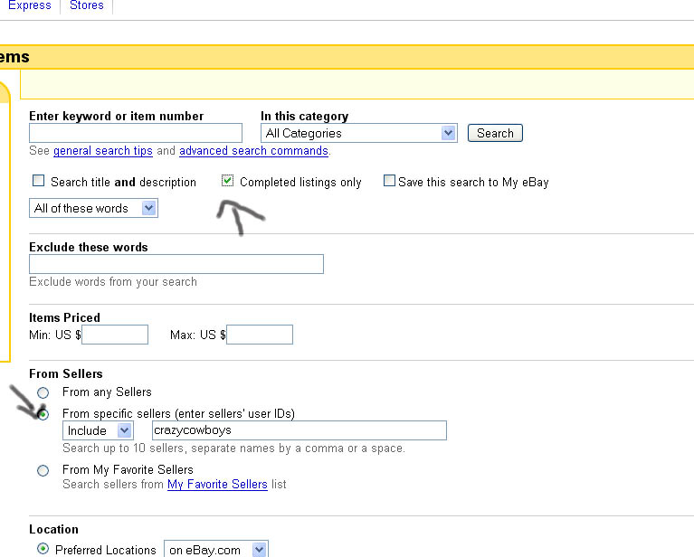

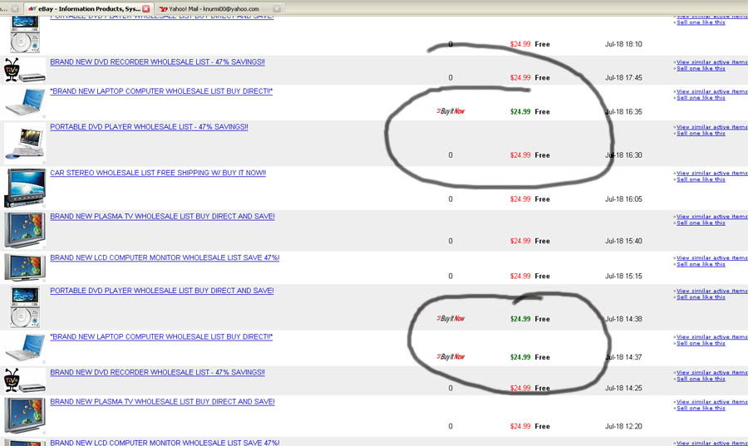

Crazycowboys – He sells many digital products, and has lots of success. OPEN SOURCE SOFTWARE! programmer geeks. They allow the software to be modified and distributed. Open source software is FREE. The license allows you to resell it and charge for it. It’s called the GNU public license. Just make sure the software you get has the GNU public license. What you are charging is a “hosting” or “admin fee”

Yourdropshipsource – This guy is making bank selling “Wholesale” lists. These have been around on ebay for a long time, and he sells them for $24.99 a pop. I just looked over yesterdays auctions that ended for him (July 18th) He had 67 auctions end, 21 of them sold!!! 21 x $24.99 = $524!!!! HOLY SMOKES! All for digital items. Of course, you gotta factor in listing fees, paypal fees, and final value fees. But lets say all those fees was 20% of that figure. That’s still $400 a day! I was selling the wholesale lists for a while, had a little bit of success. The biggest problem is that people don’t pay attention and they think they are getting a DVD player or a plasma TV for $24.99. So you may get some complaints, but if you make your description completely clear, you can avoid most problems. But I think I might try and work and revamp campaigns to get back into this.

Alegriarose – this seller sells all sorts of things from artscafe with success.

En-somnia – Sells all sorts of things from artscafe. Pay attention to completed listing and see which ones are selling.

There are tons more. I would recommend searching for products that is listed in artscafe, and then use the ADVANCED SEARCH tool. It is very powerful. Search completed listing to see what actually sells.
Step 3

Now is when we get some items to sell for our store. I will do one example here and you use it to branch off and create your own. Right now I know that animal novelties are very popular. Let’s take a Keeshond dog, look for an image, and setup that product on artscafe. First thing is I go to google images, and type in Keeshond. I found an image that I will use. Remember, you must use high quality images so that when transferred to the product it will be good quality, therefore less complaints and returns. Artscafe has a menu on the side “Image Templates” that gives the product and an ideal size. I found a picture of a keeshond dog.



Now, we go into arts café and upload our image. Once you get a lot of images you will need to create folders to organize yourself. Click on “File Manager” and then you can upload your image to a folder. Since animals are very popular and good selling items, create an animal folder.

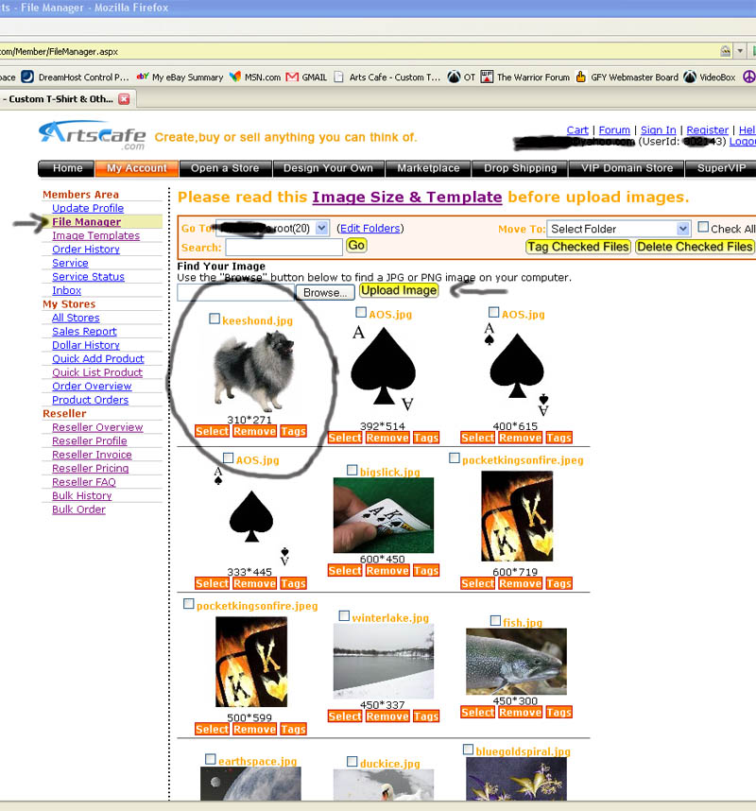

As a product, I will pick the 4 pack of rubber coasters. I’ve done well with these, and the cost from artscafe is $2.99. On average you can profit about $5-$10 on these. Remember, the more unique your product is, the more you can sell it for. After you add the product to your store, it will show up under your “Quick List Product” menu.

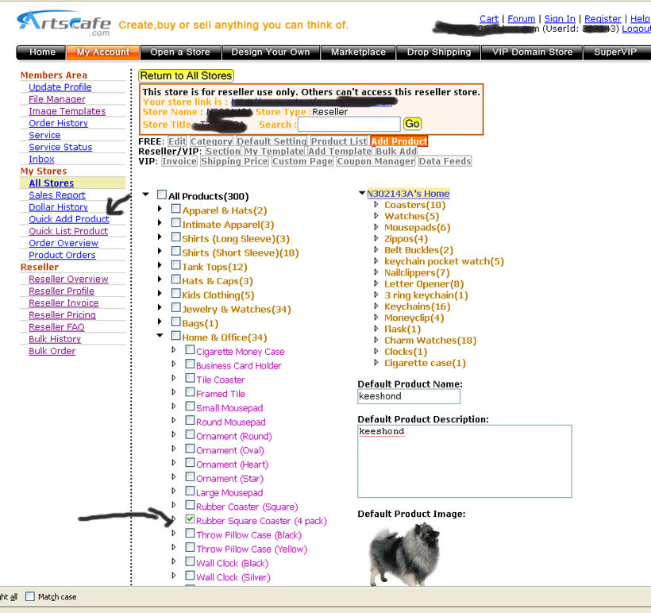

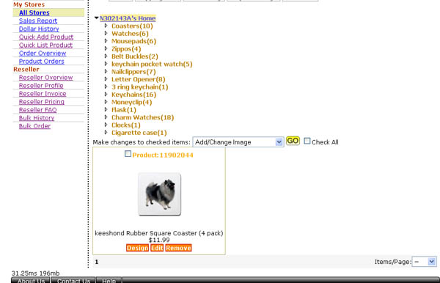

Now the product is in your store, and if you click the Design button, you can modify it slightly. I use the design button when I sell say a watch, and I want to move the image around the middle of the watch so it looks the best. By default our picture seemed to be centered and looking good. Also, you will want to click the design button so it brings up an image that we can use in our auction. Just click on “View Larger Image” Save this image to a custom folder on your desktop.
I must warn you that it will take some time to setup all your products. You have to search the web and find images, add them to your store, etc etc. But once you get them in, you will be using software to pretty much put this on autopilot.

Step 4

Ok, now that we have our products established, we need to create templates to use so we can list our auctions fast and furious. Download ebay TURBOLISTER HERE
You will create a generic template for all the different products you will be selling. One for watches, coasters, etc etc. Remember, you can get your description of the artscafe website under product info. Once you get a basic template designed, you can fill in the specifics. Like if I have one for rubber coasters my template will say “Set of 4 rubber coasters” and then when I have my different products, I can just click on the template and change the title to “Set of 4 Keeshond Dog Rubber Coasters CUTE!” You will need to spend some time creating templates for all the items you will be selling. When your done it will look something like this:

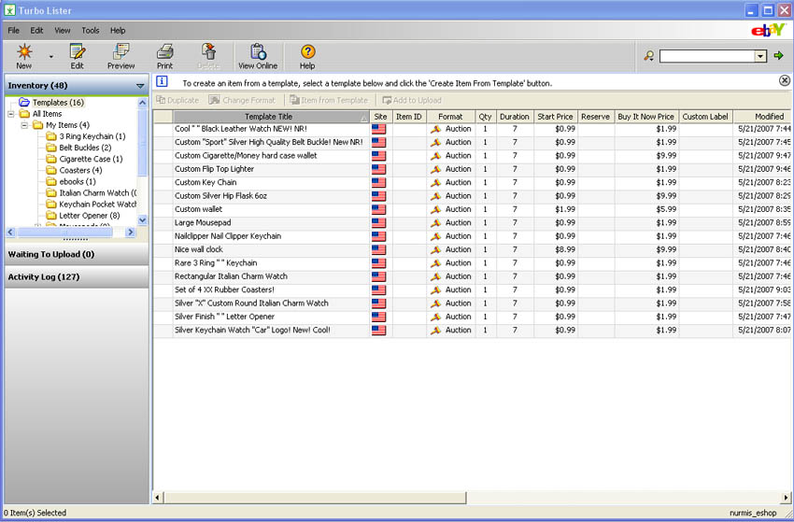

Then to create a new item from template, you simply select a template and click the “create item from template” button. Now, you can click on upload and set it up to blast them into ebay. You can duplicate auctions and list tons of them without the hassle of selling them one by one on ebay!

Step 5

Auction specific tips.
Ok when we list our auctions, I recommend setting your product to make at least $5-$6 dollars profit after costs. So if our watch costs $6.99 to buy, we want a paypal payment of at least $12, preferably in the $15 range. That’s not that hard. Many people have no problem paypaling someone $15 for a unique watch that will be shipped to their door.

There is a balance on how much you can charge for the item, and the shipping cost. People get upset when they buy something for $2 and find out it’s $10 to ship, so make sure you clearly set those terms in the auction. However, our item is being shipped from overseas, and that’s ok to do. I’ve done both where I sell the item at a BUY IT NOW price of $1.99, and charge $9.99 shipping. You can go halfway in between and charge $4.99 and $6.99 for flat rate shipping. I personally like going to smaller route because there is less of an insertion fee, and we have an excuse why our shipping is $10, because it’s coming from overseas.

I personally use Frontpage to create my auction, and then just insert the HTML into turbolister. You can use any old HTML editor, in fact there are many free ones if you do not have frontpage that work just as well. Just google “Free HTML editor” I actually used some templates that I bought on ebay (they can be found for free as well, just google “free ebay auction template”) for .99c, and they look very nice. Once you load the template into your auction, you can simply change the text to your description, and add the picture.

Ok, I want to give some successful auctions of the products we are selling, and you can use this as a base to think of a product that might be hot, and we are going to try and sell a boatload of them

One Hill TV Watch Sold for $19.03 (cost $6.99)
Ghost in the Shell watch sold for $19.98 (cost $6.99)
Basic soccer ball watch sold for $16.99 (cost $6.99)
Pirate Round Metal watch sold for $25.07 (cost $6.99)

Continue on to find out a huge way to sell multiple quantites of these items in one 10 day auction!

Ok, this is what we are going to do. We create a hot product, whipped up a nice ad, and have the HTML for it. This is my mind blowing technique to get more views, more bids, and more profit. I don’t use turbolister for this as I just go right through ebay sell tab.

The Mind Blowing Listing Technique

This costs more to list, as we will be taking advantage of the Feature Plus! Upgrade. It costs $20 to list, plus insertion fees. So if we sell a watch at $14.99, and the cost is $6.99, that’s $8 markup per watch. Let’s factor in some fees, which is probably going to be roughly $1.75 per watch, but for simplicities sake, lets just say $2. We make a $6 profit per watch. We would need to sell 3-4 watches to break even on the listing, anything after that is profit. But with this method don’t be surprised if you sell 15, 20 or more watches in one 10 day ad!!! How will we do this? Well, after you do the “feature plus! Upgrade”, once or twice a day, or as many as you want, you will go to your item under your “My ebay” tab, and click revise. Don’t change anything, just go all the way to the bottom and click Save and Continue. Next page you will click Save changes. BOOM! Your auction gets relisted at the TOP of the category. So if you are selling a mens wristwatch, and you list it in that category at the top, you know how many ebayers shop by category and browser through? Your ad will be the first one they see!!! You can upgrade your ad more by doing a highlight or bold. You should experiment and see if the extra costs are worth it. I sometimes will do highlight, but usually just bold as it’s only $1.00 more and Bold definitely catches eyes.

Step 6

Ok, so we have sold our item on ebay, now we gotta use artscafe and get the item out to our customer. Essentially, artscafe has a “Bulk Order”menu at the left of the screen. From there, gather your customer addresses from your PAYPAL payment you received from them, and paste it into the form. You then tell artscafe which product to send them by the unique product number it creates when you create an item in your inventory. Here is a listing of the step by step videos that show how to use artscafe

- Reseller-01, How to get a FREE personalized mousepads exclusive offer for resellers? The coupon code for FREE mousepads was shown inside this demo.
- Reseller-02, How to place Reseller Bulk Order (multiple addresses)?
- Reseller-03, How to get our dropship system and eBay/Paypal processing faster?
- Reseller-04, How to add different sections and sub-sections?
- Reseller-05, How to add some certain products into certain sections?
- Reseller-06, How to move products from A Section to B Section?
- Reseller-07, How to do BULK ADD products to your store?
- Reseller-08, How to customize the invoice header and footer?
Tips
- Research research research! Look for products that are popular and selling by utilizing the Advanced Search and Completed item search function on ebay. You will waste money by listing a bunch of stuff that isn’t selling or isn’t popular
- When you think of a kick butt product and want to do a 10 day feature plus! Listing, make sure you revise your item at least once or twice a day. The more you revise (even without changing anything) the more it shows back up at the top of the category!
- You can customize your invoices that your customers receive so it looks like it came from your real business.
- Make sure after you put up your auction, you search for it and view your auction and see if there are any mistakes, dead pictures, etc etc.
- Experiment with digital products as well. It’s a bit tougher, but if you whip up a good ad, have a decent product, and learn from successful sellers, you will make money. Personally, I get blown away by “yourdropshipsource” as he is probably making $300 a day or more in profit selling “Wholesale” lists.

IMPORTANT!!!!

When I first started selling, I was like, what would sell? And I was making bank, but ebay shut me down. I was selling car logo watches, like BMW, Toyota, etc. They sold like hotcakes. However, many companies search for fakes on ebay and report them. If you get reported, ebay shuts down your auction, and for repeated violations they may suspend your account. You cannot describe these brands or compare them to in your auction. For example, artscafe has a popular lighter that looks like zippo lighters. I listed them as “flip top lighter” in the description I wrote, cool lighter, just like Zippo and BAM! They shut off all my auctions. Some items are in question, like celebrities and stuff. Many are selling on ebay with no problems. I would research sellers that have been selling items for a long time as see if they are consistently making sales. Here are some suggestions: Search google for public domain or free images. There are TONS. Animal pictures are very popular.

This is going to wrap up this report. Please leave some comments in the warrior forum thread on this. If you have any questions, you may email them to me at kevinnurmi@hotmail.com

